Contact person:
Barbara Weber
Barbara.Weber@profibus.com
+49 (0) 721 96 58 549

P R E S S R E L E A S E

PROFINET: The World’s Leading Industrial Ethernet System

Karlsruhe, January 14, 2020: The latest research from IHS Markit | Technology, now a part of Informa Tech, analyzing industrial communications shows that PROFINET, the industrial Ethernet communication system of PROFIBUS & PROFINET International (PI), is widely adopted in industry. In terms of newly connected nodes, PROFINET represented a market share of nearly 30% in 2018, making it the world’s leading Ethernet-based communication solution for industrial automation.
And, 30 years after the founding of PI, this success is no accident. From the very start, notable manufacturers collaborated on a joint fieldbus, PROFIBUS – and then on PROFINET, which tackles the increasing demands of a wide range of industries with a consistent and future-proof approach. At the same time, they worked on the development and market launch of IO-Link, the communication system for sensors and actuators. Today, the Advisory Board alone – the highest technical decision-making body – contains members representing 15 global manufacturers and innovative universities. But that’s just the tip of the iceberg. In 2019, in the various working groups, over 600 employees of PI member companies contributed to the development and advancement of new or existing technologies based on the requirements of the Industry 4.0 environment, on the maintenance of established technologies for increasing quality and on operational support measures for users. Altogether, there were far more than 250 meetings during the year 2019. This averaged one meeting per workday, geared toward the technology and marketing of PROFINET, PROFIBUS or IO-Link.

Just like then, data transfer remains the focus of our work today. At PROFINET today, this especially involves the topic of time-sensitive networking (TSN) and Ethernet APL for the process industry. With IO-Link Wireless, the field of wireless communication was recently added at IO-Link. But the semantic description of data is also taking on increasing weight in the working groups. PI is thus ensuring that its technologies remain at the forefront of the industrial market, even into the future.

***

Graphic: The latest research from IHS Markit | Technology, now a part of Informa Tech, analyzing industrial communications shows that with a market share in 2018 of nearly 30 percent of the newly connected nodes, PROFINET is the world’s leading Ethernet-based communication solution for industrial automation.

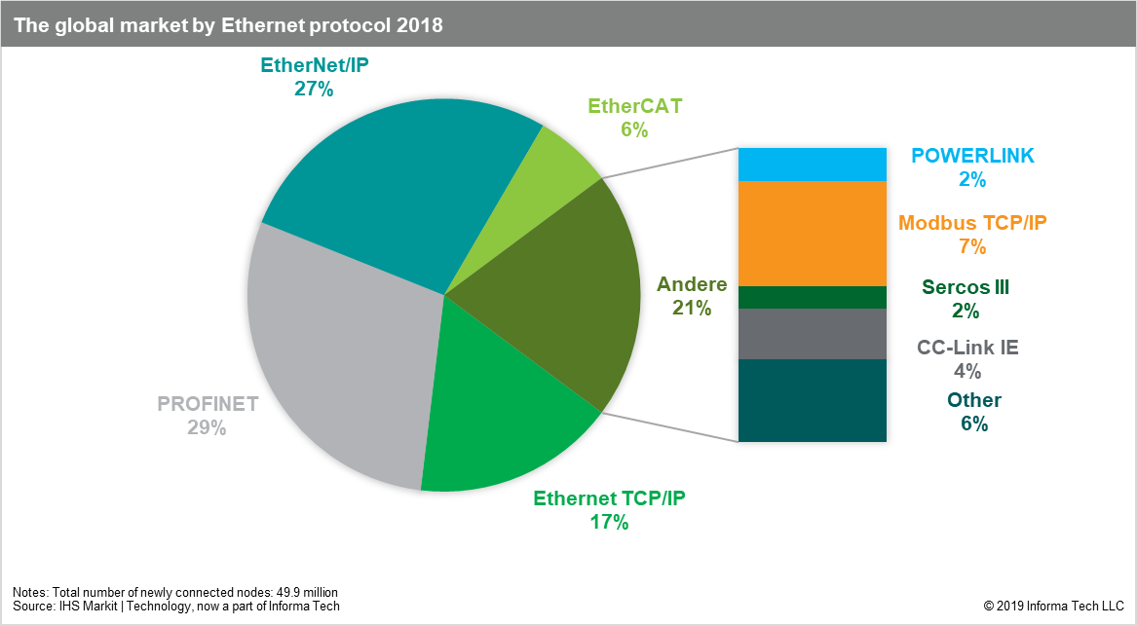

Press contact:
PI (PROFIBUS & PROFINET International)
PROFIBUS Nutzerorganisation e. V.
Barbara Weber

Haid-und-Neu-Str. 7

D-76131 Karlsruhe, Germany
Phone: +49 (0) 721 / 96 58 549

Fax: +49 (0) 721 / 96 58 589
Barbara.Weber@profibus.com
http://www.PROFIBUS.com
The text of this press release is available for download at www.profibus.com.

