P R E S S R E L E A S E

For locating and orientation: omlox locating technology continues its ascent

Karlsruhe, Germany – January 01, 2024: The omlox technology group is continuing to expand its range in new industries all the time. As a result, omlox-based systems are now being used in the healthcare sector, retail trade, energy supply and mining, in addition to many applications in mechanical engineering and logistics. “The working group now oversees more than 300 use cases,” said Dr. Matthias Jöst, Head of the Committee omlox at PI (PROFIBUS & PROFINET International).

Knowing the “where”—that is, the precise locating of items and equipment—concerns just about every area of life, from the daily search for a key to the localization of tools on a shop floor and from the tracking of medical equipment at hospitals to the locating of shipments throughout the delivery process. “The advantages of the omlox real-time localization system are able to truly shine in applications like this,” explained Dr. Jöst. “Open, manufacturer-independent omlox technology makes it possible to exchange position data regardless of the manufacturer.” The major advantage here is that omlox enables the integration of industrial software and hardware solutions in a shared ecosystem. This makes it possible for companies to use a single infrastructure in different applications from different suppliers. As omlox makes all locating technology available via standardized APIs, the wide variety of implementation variants do not face limitations or restrictions—depending on the industry and use case.

In addition to suppliers of UWB locating technology, the omlox community now also includes manufacturers of LiDaR, Bluetooth & ultrasonic sensors and GNSS. This enables the seamless locating of objects from the global scale all the way down to the millimeter scale on a desk, and the technology is now being rolled out across the world. In early December, the omlox community met up in China, where an integrated demo was presented by Chinese technology suppliers.
International standardization is continuing to advance as well. Thanks to cooperation with several associations, such as the OPC Foundation and the Industrial Digital Twin Association (IDTA), the vision of transparent data exchange along the value-creation chain is one crucial step closer to reality. The OPC is currently working on a companion specification for locating. ECLASS 14 now includes a locating concept for products, and sub-model asset locating for the mapping of spatial product traceability will be completed by the IDTA by year’s end. This makes it possible to locate a product throughout its entire life cycle.

***

Graphic: With omlox, position data can be exchanged regardless of the manufacturer.
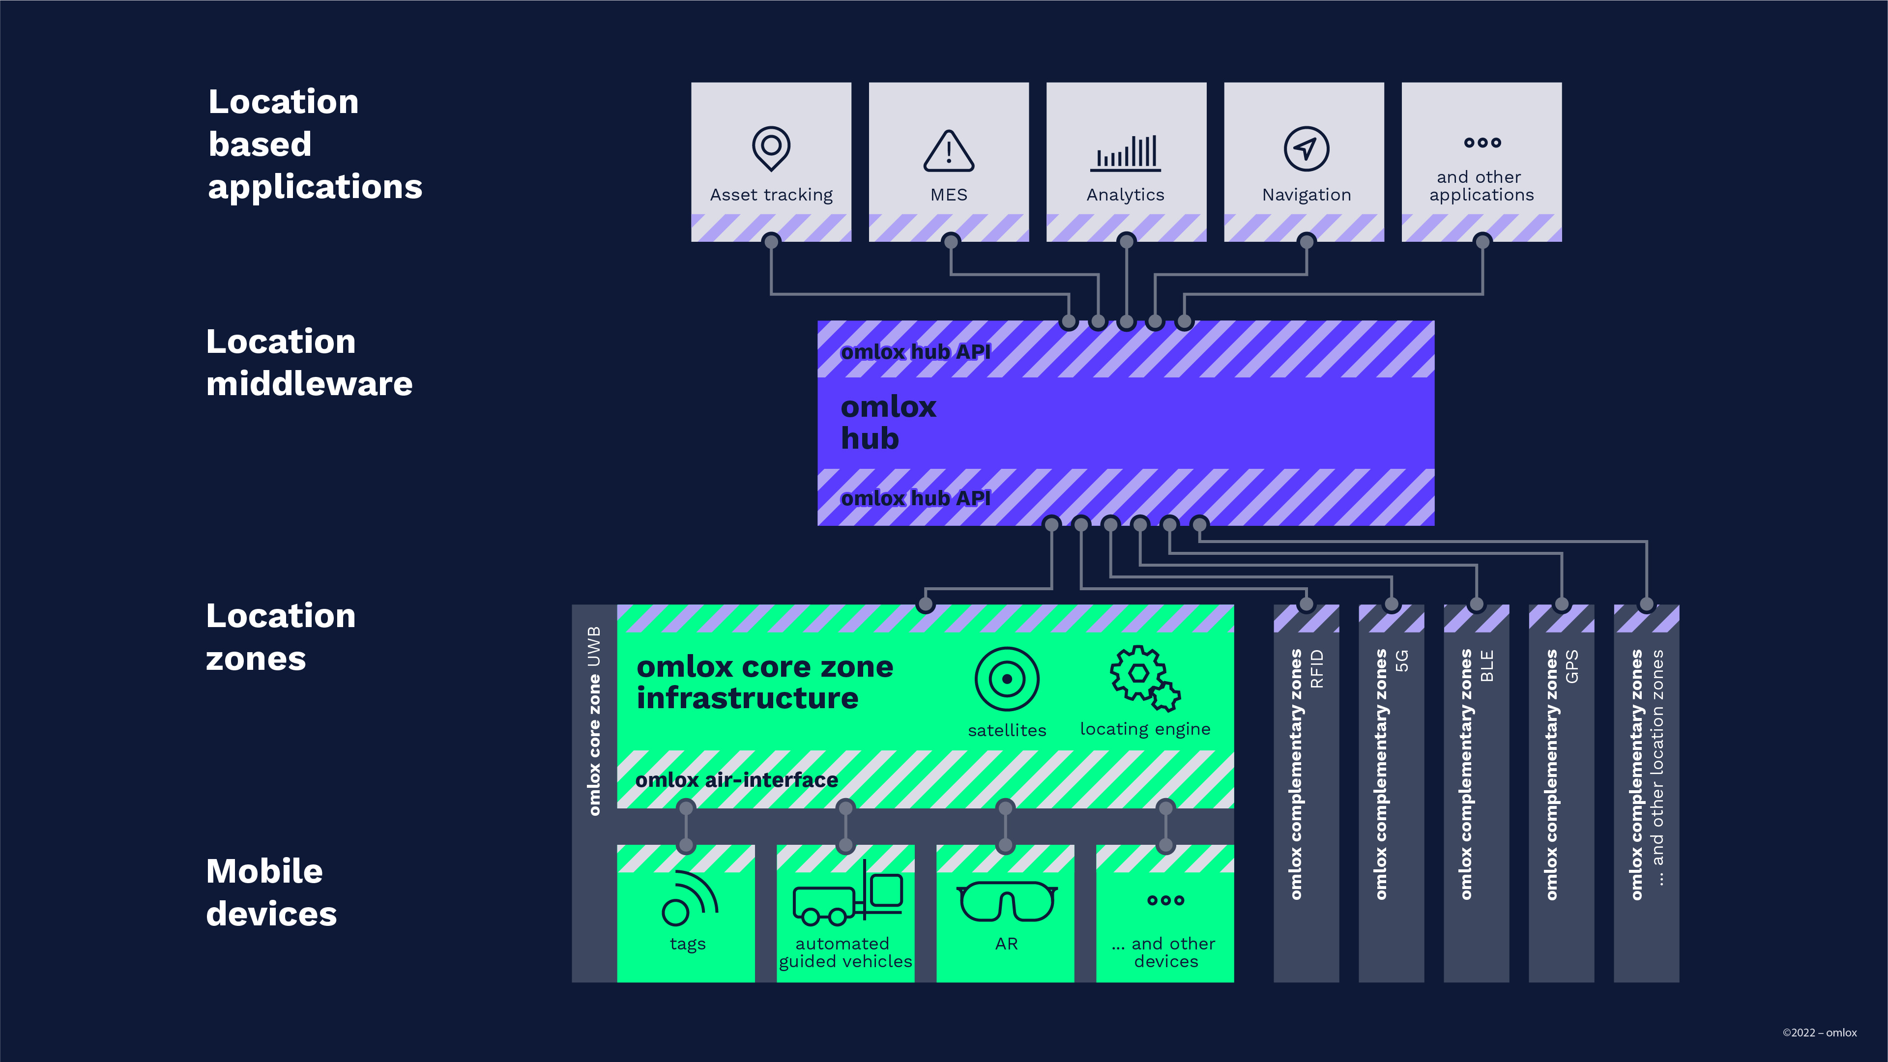
Press contact:
PI (PROFIBUS & PROFINET International)
PROFIBUS Nutzerorganisation e. V.
Barbara Weber

Ohiostraße 8

D-76149 Karlsruhe, Germany
Phone: +49 7 21/96 58 5 49

Fax: +49 7 21/96 58 5 89
Barbara.Weber@profibus.com
http://www.PROFIBUS.com
The text of this press release is available for download at www.profibus.com.

