Contact person:
Barbara Weber
Barbara.Weber@profibus.com
+49 721 9658-549

P R E S S R E L E A S E

First maintenance update of PROFINET specification V2.4 is complete

Karlsruhe, Germany – 23 July 2020: Digitization and Industry 4.0 are presenting new challenges in automation. Since the very beginning, PROFIBUS & PROFINET International (PI) have been taking on new challenges and working consistently toward overcoming them using their technology – and only that technology which can be developed in an agile way is future proof. That's why PI is continually developing the basic specification for PROFINET while maintaining compatibility.

In this vein, the first maintenance update of the PROFINET V2.4 specification – which integrated TSN for the first time last year – has been compiled and completed by the active PROFINET Working Group according to current technological development and customer requirements.

As part of TSN integration maintenance, current IEEE802 specifications such as 802.1AS-2020 synchronization are referenced. The latest results of cross-organizational coordination in IEC/IEEE 60802 for a convergent TSN network were also integrated right away thanks to active and qualified participation in these bodies. Naturally, from the implementations of the initial version of the specification which were started also resulted improvements and supplements to details.

A second crucial supplement was the inclusion of MAU types (Medium Attachment Unit) from 10 Mbit/s to 10 Gbit/s for existing conformance classes A and B. 10 Mbit/s is required for PA devices with Ethernet APL physics (Advanced Physical Layer). This results in specific additional entries for the network timing calculation and diagnostics. Device modeling with all tested functions like system redundancy and PA Profile 4.0 remains unchanged.

The first stage of a security enhancement was also specified in close cooperation between the experts of the Security and the PROFINET Working Group. For one thing, this makes it possible to more precisely limit the behavior of address issuance and SNMP querying. Tampering with the GSD can also be identified thanks to additional signing.

In addition to the specification, the corresponding guidelines were updated as well. Specific topics like the use of TSN and redundancy are explained in a comprehensible way in these documents. The latest version of the PROFINET tester for certification and a trail bundle for initial TSN tests are also available alongside the specification.

A "living" standard has to continually implement current technological developments and customer requirements in the respective specifications, supplemental guidelines, workshops etc. – and it has to do it in an open and transparent way for all involved. It's the only way to ensure success, both today and in the future.

***

Graphics:
Using IEEE and PROFINET standards as a basis, PI is consistently maintaining and expanding the PROFINET over TSN specification.

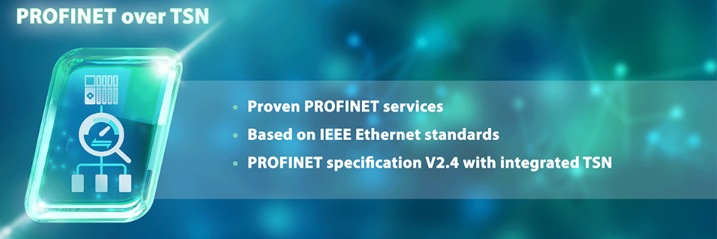

Press contact:
PI (PROFIBUS & PROFINET International)
PROFIBUS Nutzerorganisation e. V.
Barbara Weber

Haid-und-Neu-Str. 7

D-76131 Karlsruhe, Germany
Phone: +49 7 21/96 58 - 5 49

Fax: +49 7 21/96 58 - 5 89
Barbara.Weber@profibus.com
http://www.PROFIBUS.com
This press release is available for download at www.profibus.com.

