Contact person:
Barbara Weber
Barbara.Weber@profibus.com
+49 721 9658-549

P R E S S R E L E A S E

Sensor-to-Cloud with IO-Link via OPC UA

Nuremberg, November 28, 2018: IO-Link was originally developed in order to provide easy standardized wiring of intelligent, complex sensors and actuators using a simple three-core sensor cable. As the issues surrounding Industry 4.0 grew more specific, it quickly became clear that IO-Link is the key in implementing powerful Industry 4.0 concepts, since a wide variety of field information is required from production plants.

Besides the control of automated production and device configuration, this information is increasingly needed for remote maintenance, asset management, predictive maintenance, condition monitoring, and data analytics in order to optimize production and make it more flexible. These tasks are based on open sensor-to-cloud communication. Having completed IO-Link’s safety and wireless technological features, the IO-Link Community undertook this new challenge and – in cooperation with the OPC Foundation – began working on a companion specification, “OPC UA for IO-Link.” The decision in favor of OPC UA was the result of the widely accepted standardized semantic description of the data to be transmitted as well as its relation to the “language” of automation.

In an initial step, main application cases were defined in an IO-Link working group that represented over 20 companies. This formed the basis for drafting the companion specification, in cooperation with experts from OPC UA. The contents were derived from the OPC Foundation specification “OPC UA Device Interface,” which contains the generic model of a field device. The underlying architectural model guarantees conformity with all other field devices that are based on OPC UA.
This companion specification passed a review by the IO-Link Community and the OPC Foundation; the final version V1.0 was then drawn up and adopted. The first implementations and examples were prepared for the SPS IPC Drives trade fair in November 2018.

An IO-Link Community working group then began the task of defining the JSON data-interchange format for IO-Link; defining this internationally recognized data format would allow for configuration tools to be connected independent of manufacturer and for lean sensor-to-cloud applications to be implemented.
***

Graphic: The Y-Gateway” is sending sensor data to PLC and the cloud in parallel.
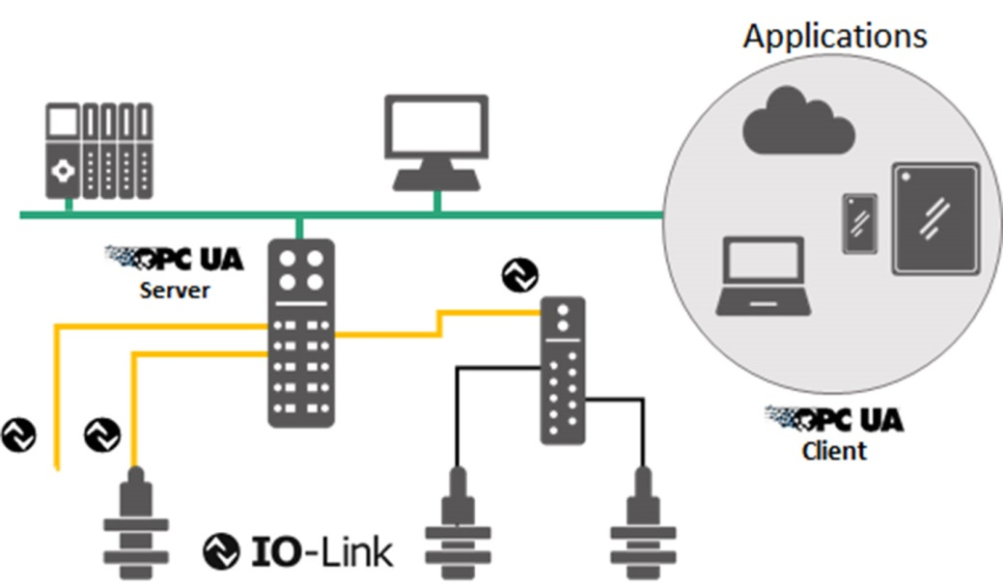

Press contact:
PI (PROFIBUS & PROFINET International)
PROFIBUS Nutzerorganisation e. V.
Barbara Weber

Haid-und-Neu-Strasse 7

76131 Karlsruhe, Germany
Phone: +49 721 96 58 549

Fax: +49 721 96 58 589
Barbara.Weber@profibus.com
http://www.PROFIBUS.com
The press release is available for download at www.profibus.com.

