P R E S S R E L E A S E

Free IO-Link Safety Training

Karlsruhe, Germany – March 10, 2021: The IO-Link Community has initiated a new concept for IO-Link Safety workshops. These workshops will be divided into two training sessions on April 20 and 27. The respective training unit will be available twice a day: in the morning starting at 8:00 am CET and in the afternoon starting at 4:00 pm CET.

During these times, the IO-Link Safety workshop will be conducted digitally as a webinar – i.e. with sufficient “safety” distance! People interested in IO-Link will therefore be able to obtain comprehensive information from the comfort of their own office or home, despite travel restrictions or social distancing rules.

The free English webinars will take place at one-week intervals. A training unit will be held from 8:00 to 11:00 am CET and then repeated from 4:00 to 7:00 pm CET, giving participants from different time zones worldwide the opportunity to attend the webinar.

In addition to the functionally secure communication protocol, IO-Link Safety offers other important functions such as disconnection detection, parameter backup and restore, etc. The webinar provides deep insight into all design and security aspects of the IO-Link Safety technology and associated specifications, as well as a comprehensive overview of IO-Link Safety’s development process. In the process, architecture and implementation questions will be answered and the available development and test support will be presented and explained. Other items on the agenda include the security assessment and certification.

For more information on the content of the webinar and on registration, please visit the IO-Link website at www.io-link.com.

***

Graphic: The IO-Link Community is offering a free of charge IO-Link Safety Training in English in April.
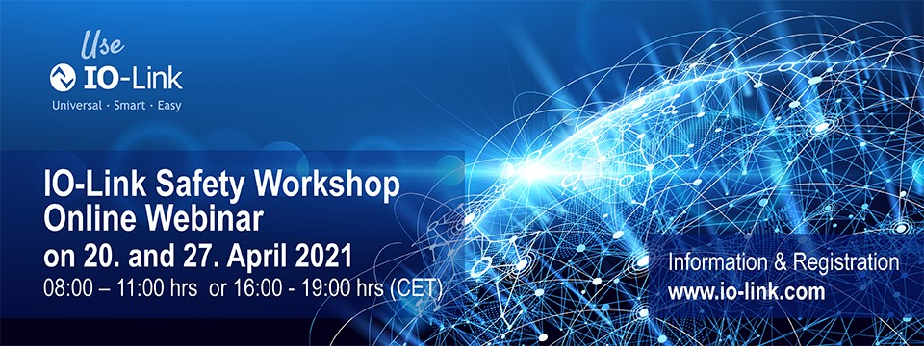

Press contact:
PI (PROFIBUS & PROFINET International)
PROFIBUS Nutzerorganisation e. V.
Barbara Weber

Haid-und-Neu-Str. 7

D-76131 Karlsruhe, Germany
Phone: +49 (0) 7 21/96 58-5 49

Fax: +49 (0) 7 21/96 58-5 89
Barbara.Weber@profibus.com
http://www.PROFIBUS.com

The text of this press release is available for download at www.profibus.com.

