Contact person:
Barbara Weber
Barbara.Weber@profibus.com
+49 721 9658-549

P R E S S R E L E A S E

The goals of integration of TSN into PROFINET

Hanover - Germany, April 25, 2017: A promising new IEEE technology for Ethernet that combines the bandwidth of IT (information technology) networks with the latency of OT (operational technology) networks is in the offing in the form of TSN (Time-sensitive Networking). TSN consists of a tool kit of standardized mechanisms that can be used in Ethernet-based networks. In the PI (PROFIBUS & PROFINET International) “Industry 4.0” working group, the requirements and goals for the future use of TSN in PROFINET have now been worked out.

The focus of the work is first and foremost on easy handling for PROFINET users. They should be able to use the new technology easily in their devices or systems while still taking advantage of the existing knowledge. Furthermore, services such as diagnosis, parameterization, etc. should be identical as in the current landscape. The engineering, i.e. the configuration of the network, should also be performed in the familiar way. In this way PI permits an easy transition to the new Ethernet landscape and ensures broad acceptance among users.

In addition, PI relies on standard Ethernet technology so it can both draw on a broad selection of Ethernet chips for the implementation of the PROFINET interface on devices and also benefit from the further developments of IEEE technology such as gigabit bandwidths. Furthermore, synchronous networks can be implemented for isochronous applications with TSN. Previously, networks had to be set up separately and integrated in dedicated chips in the devices. This is the only way to ensure not only that PROFINET remains future-proof for users, but also that simpler setups will be possible.
Besides a stack architecture that is easy to integrate and scale, a further crucial goal for the use of the technology is a high degree of determinism and robustness to IP-based traffic that is not real-time capable. The reliability increases, since TSN allows bandwidth to be reserved on the network for individual tasks so they are not disrupted by other traffic. This is especially important, since a variety of protocols will be used side by side in future in Industry 4.0 networks. In this way PI incorporates parallel communication via OPC UA between stations on the system level or from devices on the field level to the cloud right from the start.

However, with the introduction of TSN, it is also necessary to simplify the engineering of the network for more complex systems, until they become plug-and-work-capable networks that permit reconfiguration during ongoing operation. In addition, the TSN mechanisms that arise alongside the real-time protocol procedure offer the options that PI is consistently pursuing.

Karsten Schneider, Chairman of PI, summarizes the benefits of this approach thus: “PI will expand PROFINET with the mechanisms of TSN in layer 2, retaining the application layer on the higher levels. This makes it possible to migrate the applications to the new technology simply and incrementally and to take advantage of the advantages of an open, globally standardized IT technology.”

***

Graphic: PROFINET architecture with TSN
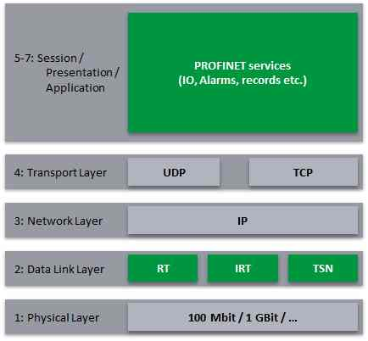
Press contact:
PI (PROFIBUS & PROFINET International)
PROFIBUS Nutzerorganisation e. V.
Barbara Weber

Haid-und-Neu-Strasse 7

D-76131 Karlsruhe, Germany
Tel.: +49 (721) 96 58 - 5 49

Fax: +49 (721) 96 58 - 5 89
Barbara.Weber@profibus.com
http://www.PROFIBUS.com
The press release is available for download at www.profibus.com,

