P R E S S R E L E A S E

MTP added to PI technology portfolio

Karlsruhe, Germany – December 02, 2021: The production of modern goods requires production plants of ever-increasing complexity. The time and effort required for planning, configuration and commissioning is increasing, and costs are rising accordingly as well. This is where Module Type Package (MTP) technology comes into play. The modularization of a production plant makes it possible to use standardized plant parts. Flexibility can also be increased in this way. As a result, changes can be made to production plants more easily. MTP was created by NAMUR and ZVEI. In PROFIBUS & PROFINET International (PI), both organizations have found a solid partner for the further development, quality assurance and international distribution of MTP.

Cooperation with other organizations and associations is nothing new to PI. For 10 years now, it’s been impressively demonstrating with FDI that successful technology can be brought to market more quickly through cooperation. The latest example of this is Ethernet-APL, which was also created from NAMUR requirements. NAMUR and ZVEI will therefore continue to play an important role with MTP and establish requirements for the technology. PI will then take it from there, specifying them in detail in technology and marketing working groups (for the purpose of creating national and international standards) and handling their distribution on the market.

PI will also contribute its experience in training and certification to develop offers for MTP. Training courses introduce both manufacturers of MTP solutions and users of the technology to it more quickly. A well-developed certification concept is the basis of cross-manufacturer interoperability. PI has many years of experience in both areas. With its 53 competence centers, 31 training centers and nine testing labs around the world, PI is optimally positioned for MTP. “We see MTP as the ideal complement to our technology,” said Karsten Schneider, Chairman of PI, with delight. “PI is currently transforming from a fieldbus organization to a real enabler of Industry 4.0 in the production sector.” Technology like MTP will continue to sharpen this profile. “We unite manufacturers of automation solutions for production automation and the process industry like no other organization,” continued Schneider.

Modular production with MTP is seen as an important part of digitization in the production industry. Essential plant KPIs are expected to improve considerably thanks to MTP. On average, experts expect that the time to market introduction can be halved, engineering expenditure can be reduced by 70 percent and flexibility can be increased by 80 percent. Having been selected as host, PI will now set up the appropriate working groups and get started with MTP.

***

Graphic: MTP fits perfectly into PI's technology portfolio.
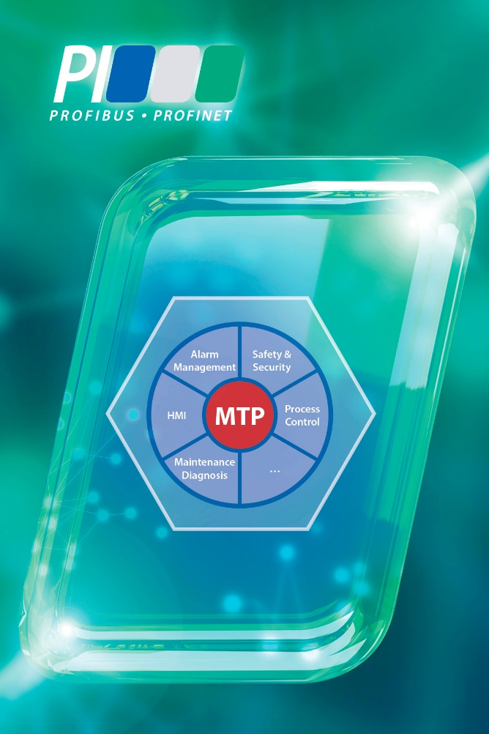
Press contact:
PI (PROFIBUS & PROFINET International)
PROFIBUS Nutzerorganisation e. V.
Barbara Weber

Haid-und-Neu-Str. 7

D-76131 Karlsruhe, Germany
Phone: +49 7 21 986 197-49

Fax: +49 7 21 986 197-11
Barbara.Weber@profibus.com
http://www.profibus.com
The text of this press release is available for download at www.profibus.com.

