P R E S S R E L E A S E

A stable foundation for PROFINET over TSN
Nuremberg, Germany – November 9, 2022: With completion of the V2.4 MU3 documentation, the experts at PI (PROFIBUS and PROFINET International) finished the specification work for PROFINET over TSN in mid 2022. The scope and depth of all the required TSN functions and the corresponding configuration using PROFINET resources are described in detail. Naturally, experience gained from the initial implementations and current further developments of the IEEE have been taken into account for eliminating the last remaining gaps and ambiguities. As always, change management followed a transparent and open process so that technology manufacturers can also address these details in a planned way. This specification is also a template for the currently-in-progress maintenance cycle of the IEC61158/IEC61784.

With the availability of PROFINET specification V2.4 MU3, the technology integrators have a stable foundation for both hardware and software. Early adopters can still expand or refine the interface packages which have already been created by integrating the newly specified details in the specification. Those just getting started have a clear and comprehensive foundation for implementation. This version has been declared a “long-time” version with the specified function scope and thereby offers technology and device manufacturers a sturdy foundation for their product planning and development.

In addition to the specification, comprehensive and practice-oriented testing is required as part of certification, which ultimately ensures interoperability when used in an application. In the meantime, the new testing system required for TSN has been introduced on a TSN-capable platform and already sees daily use by PI Test Labs and the testing departments of manufacturers. An initial basic set of test cases for TSN is already available, and additional test cases will follow, step by step, to ensure the required testing scope with the next official test version.

Many interested members of the PI community and users have been learning about the status of PROFINET over TSN over the past few weeks and months at a host of national and international workshops and events. In addition to the advantages of TSN, application and launch scenarios in systems were a very popular topic.

The current status of the implementation from different manufacturers, a clear presentation of the advantages of TSN and the testing environment can be seen in new demos at the PI stand at the SPS trade show.

***
Graphic: The PROFINET over TSN demo at SPS with implementations from different manufacturers.
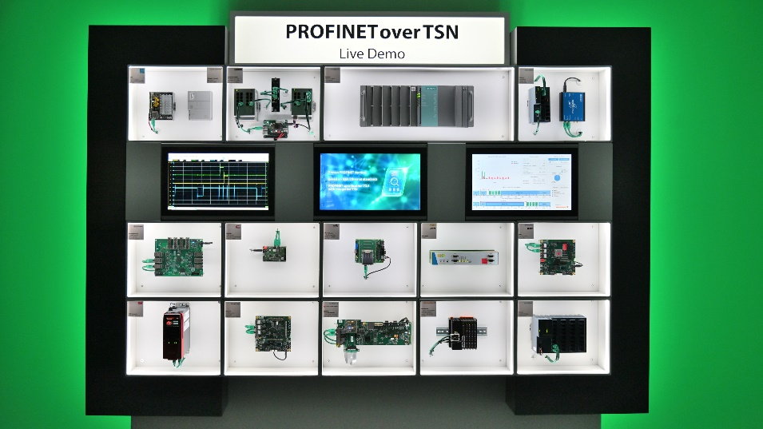

Press contact:
PI (PROFIBUS & PROFINET International)
PROFIBUS Nutzerorganisation e. V.
Barbara Weber

Haid-und-Neu-Str. 7

D-76131 Karlsruhe, Germany
Phone: +49 721 986 197 49
Barbara.Weber@profibus.com
http://www.PROFIBUS.com
The text of this press release is available for download at www.profibus.com.

