Contact person:
Barbara Weber
Barbara.Weber@profibus.com
+49 721 9658-549

P R E S S R E L E A S E

Confirmed Quality with Automated Tests

Karlsruhe, July 11, 2019: During the development and enhancement of PROFINET devices, developers and system testers have extensively and successfully used the continuously expanded Automated RT tester (ART tester) from PI (PROFIBUS & PROFINET International). This has become an important component of quality assurance, and an increasing number of device manufacturers are integrating it in their testing during the development process. This is the feedback of the PI community from the most recent events and meetings.

The automated and clearly understandable test sequences help to substantially raise the quality and stability of the communication firmware. The tester recognizes errors that can typically result from adjustments for new devices – in a way that is reliable and replicable. Thus, the user receives access to a PROFINET device with guaranteed quality. Thus problems of interoperability are avoided and manufacturers can forgo the troublesome search for errors.

The tester is being developed by a team of professional developers in close coordination with standardization authorities, quality assurance committees and technology suppliers, based on the latest procedural methods (Scrum-based agile software development and the corresponding tools). The globally accredited PI test labs use this tester for their certification testing. But device manufacturers can also use this very software to carry out and reproduce identical tests in-house. The PI labs were most recently trained during the international test lab meeting in Innsbruck at the end of May 2019; the device manufacturers were likewise trained at the certification workshop in Mainz in June 2019.

Meanwhile, developers often use the ART not only to complete a project but also for parallel testing during the development process. The tester can do such things as running a test during the night for coding that was developed earlier that day, in order to get the fastest possible response concerning certifiability. A further advantage of the testing system is that it can be used as the base for one’s own test case development. A company can easily supplement its own test sequences by means of C#, using the available functions and methods.

Along with the current testing bundle – which primarily contains the new version of the ART with enhanced redundancy tests and now also with integrated topology tests – a further, separate bundle is available with the pilot version for PROFINET with TSN. This enables developers to collect initial experience at an early stage with the new system and PROFINET with TSN, which supports PI’s objective of using specific measures to implement easily understandable, replicable and consistent certification.

***

Image: An error-free test result is the successful conclusion to developing a device.

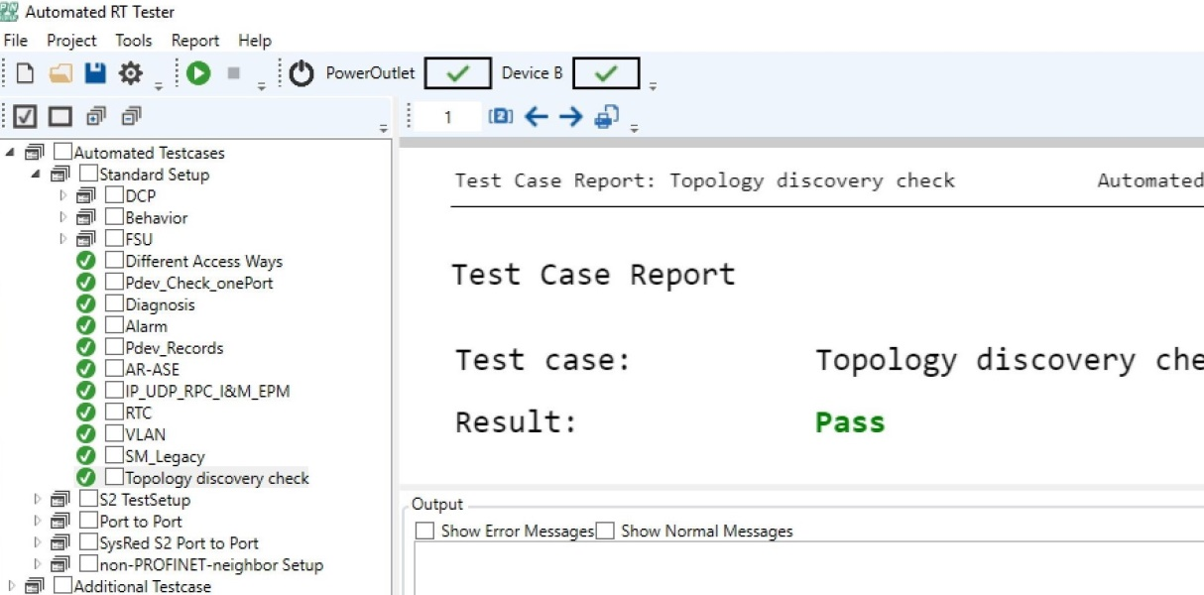

Press contact:
PI (PROFIBUS & PROFINET International)
PROFIBUS Nutzerorganisation e. V.
Barbara Weber

Haid-und-Neu-Strasse 7

76131 Karlsruhe, Germany
Phone: +49 721 / 96 58 - 5 49

Fax: +49 721 / 96 58 - 5 89
Barbara.Weber@profibus.com
http://www.PROFIBUS.com
The text of this press release is available for download at www.profibus.com.

