Contact person:
Barbara Weber
Barbara.Weber@profibus.com
+49 721 986 197-49

P R E S S R E L E A S E

Interop Workshop for IO-Link Safety FS masters and FS devices

Karlsruhe, Germany – March 08, 2022: Alongside development of the IO-Link Safety specification, technology provider companies have implemented testing systems for FS masters and FS devices, thereby ensuring a high level of maturity of test specification V1.1.

A new FS master testing system – comprised of the testing program on a Windows PC as well as test hardware acting as a pseudo FS device which can be controlled and read out – can now check all FS master functions in accordance with the test specification, including OSSDe mode. This FS master testing system also plays a big role in integration testing in safe fieldbus systems (e.g. PROFIsafe). The well-known “USB master,” which already supports the testing of standard IO-Link devices can configure and test IO-Link Safety FS devices in an expansion stage.

Discussions with testing laboratories regarding how these testing systems can be integrated into the safety certification of IO-Link Safety devices are ongoing. Safety certification itself has already been coordinated and specified in the test specification.

Initial experience with the tests was gathered by companies at the first Interop Workshop for IO-Link Safety FS masters and FS devices in November of last year. A total of seven companies tested mutual operation and test programs with five FS master implementations and six FS device implementations. This experience has already been incorporated into version 1.1 of the test specification.

Thanks to this great success, three more IO-Link Safety Interop Workshops are planned for 2022. The next one will be held on April 7 in Karlsruhe (Germany) and the other two will take place on June 30 and October 20, 2022.

Interested companies who would like to participate with their IO-Link Safety products/prototypes are asked to register early for an appointment through the IO-Link Support Center (info@io-link.com).
***
Graphic: This year, companies can test their IO-Link Safety products in mutual operation and with test programs at three IO-Link Safety Interop Workshops.
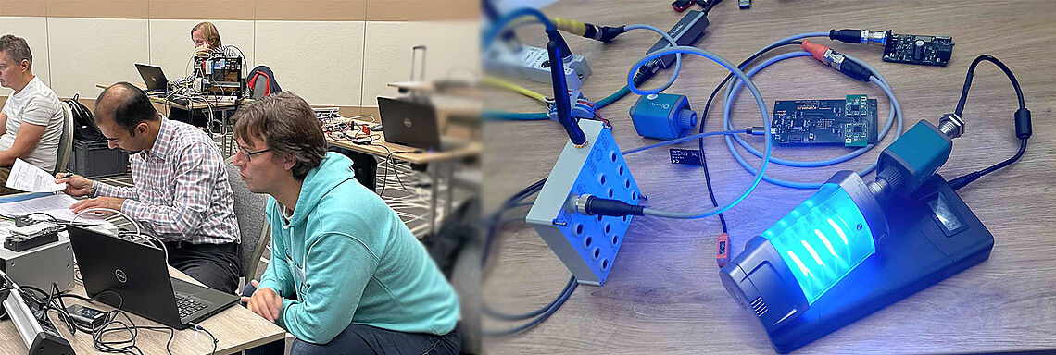
Press contact:
PI (PROFIBUS & PROFINET International)
PROFIBUS Nutzerorganisation e. V.
Barbara Weber

Haid-und-Neu-Str. 7

D-76131 Karlsruhe, Germany
Phone: +49 721 986 197-49
Fax: +49 721 986 197-11
Barbara.Weber@profibus.com
http://www.profibus.com
The text of this press release is available for download at www.profibus.com.

