Contact person:
Barbara Weber
Barbara.Weber@profibus.com
+49 (0)721 96 58 549

P R E S S R E L E A S E

Omlox wins Hermes Award 2020

Congratulations from PROFIBUS & PROFINET International

Karlsruhe – July 16, 2020: PROFIBUS & PROFINET International (PI) congratulates the industrial partners and specialists of the omlox initiative on winning the Hanover Fair’s Hermes Awards 2020. This outstanding achievement was the result of strong support from the initiative’s partnering companies and the extremely active dedication of everyone involved. “Such achievements are only possible when many committed individuals actively work together to develop a cross-company standard for a new technology. By integrating omlox in our portfolio, we at PI not only want to offer an open platform for the advancement of omlox, but introduce it through our well-established, globally active organizational form in all regions and markets throughout the world,” explains Karsten Schneider, Chairman of Profibus Nutzerorganisation e.V. (PNO) and of PROFIBUS & PROFINET International (PI).

The publication of the “Call for Experts” serves as the starting point for the activities in the five newly launched omlox working groups at PI: Use Cases, Hub, Core Zone, Marketing and Quality Test. The results of the omlox initiative and initial experiences in the pilot plants form the basis for this endeavor. “Countless discussions with interested users have yielded a wealth of new ideas for use cases, which will set the pace for further development at omlox. We still have a long way to go. The potential is far from exhausted,” states Eberhard Wahl, TRUMPF Werkzeugmaschinen GmbH + Co. KG, head of the Use Cases working group for omlox at PI.

With the progressing digitalization of production in the last years, there has been a substantial rise in interest in an open standard for positioning technology for industrial use, since it allows vendor-neutral products and solutions to be made available for logistical tasks, making it possible for positional data to be shared and used in a much more flexible way.
Omlox is an open, vendor-neutral technology, offering manufacturers and users new possibilities for implementing production processes and products that are in line with the requirements of Industry 4.0. The fact that omlox won the Hermes Award is an incentive and motivation for PI to continue pursuing its Industrie 4.0 strategy.

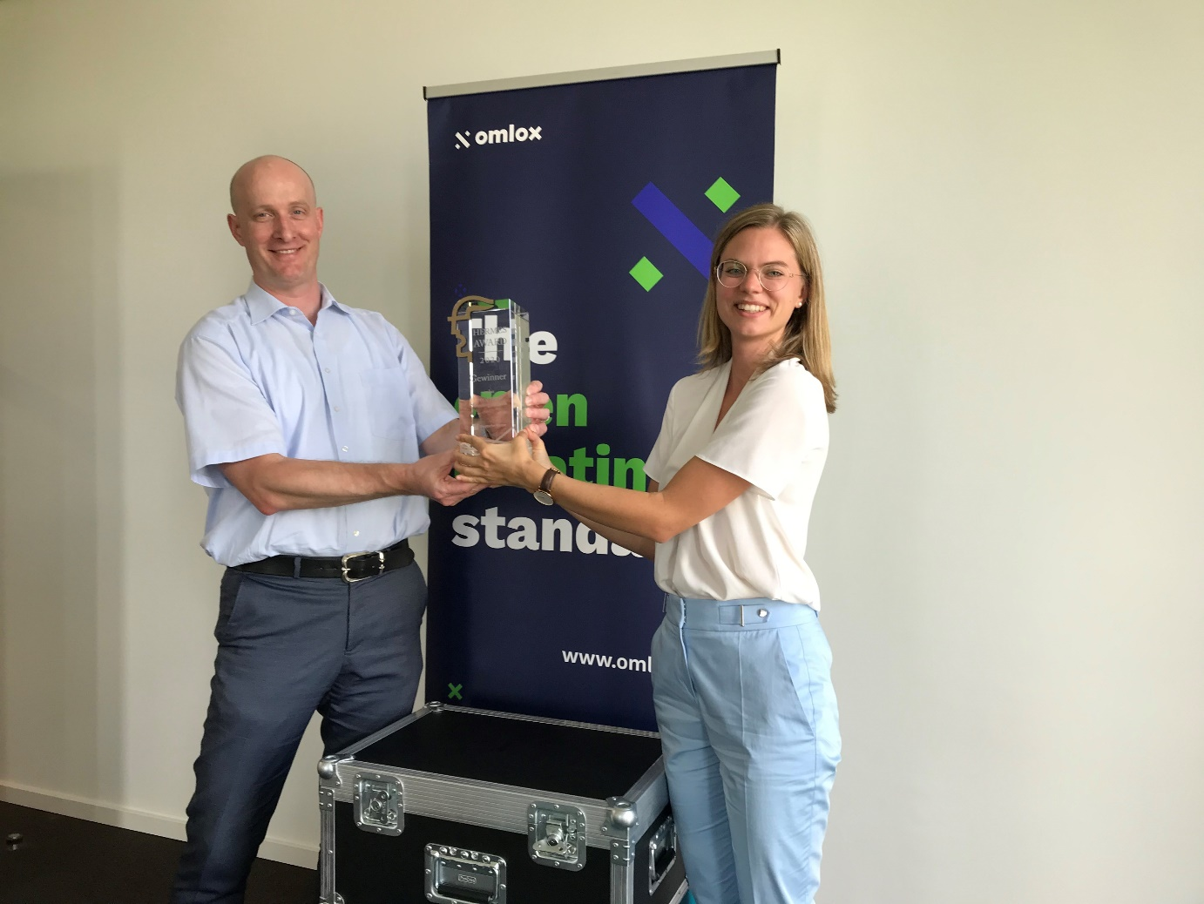

***

Photo: Dr. Matthias Jöst, Heidelberg Mobil International GmbH and committee head for omlox at PI, and Céline Daibenzeiher, TRUMPF Werkzeugmaschinen GmbH + Co. KG and head of the Marketing working group for omlox at PI, accept the Hanover Fair’s Hermes Award 2020 – virtually, due to the coronavirus pandemic.

Press contact:
PI (PROFIBUS & PROFINET International)
PROFIBUS Nutzerorganisation e. V.
Barbara Weber

Haid-und-Neu-Str. 7

D-76131 Karlsruhe, Germany
Phone: +49 (0)7 21 /96 58 - 5 49

Fax: +49 (0)7 21 / 96 58 - 5 89
Barbara.Weber@profibus.com
http://www.PROFIBUS.com
This press release is available for download at www.profibus.com.

