Contact person:
Barbara Weber
Barbara.Weber@profibus.com
+49 (0) 721 96 58 549

P R E S S R E L E A S E

Technical work on OPC UA Safety completed

Nuremberg, November 27, 2019: Modularization and interoperability are playing an ever-increasing role in modern systems and are the core requirements for Industry 4.0. PROFIBUS & PROFINET International (PI) spoke out at an early stage for OPC UA as an open, cross-vendor standard for machine-to-machine communication. However, to round out the technology, a standard for fail-safe communication had been lacking at this level. This problem has been resolved by the specification “OPC Unified Architecture, Part 15: Safety,” a joint development of the OPC Foundation and PI. The technical work has now been completed.

Since the introduction of the fieldbuses, the modularization of systems has been a driving force behind the technology. It allows for individual machines to be developed independently and then put into operation together in the system itself. With OPC UA, a technology is now in the starting blocks that allows for cross-vendor networking between machines – independent of the fieldbuses used within the machine. However, OPC UA had not previously had the possibility to transmit fail-safe data in the way that is customary for fieldbuses with PROFIsafe. Safety functions thus had to be implemented conventionally, by means of direct cabling or a coupler. This increased costs and reduced flexibility.

PI has now closed this gap in cooperation with the OPC Foundation and has completed the technical work for OPC UA Safety. The next steps have already been planned as well. For one, the development of a test specification is being launched, along with a software tool for the automated test. This includes the establishment of a certification and approval process like that of PROFIsafe. This is the prerequisite for the fast and simple safety certification of products that are implementing OPC UA Safety. For another, case examples are being developed for the purpose of demonstrating the new features of OPC UA Safety. This includes the simplified administration of secure addresses for series machines, along with the possibility of being able to communicate with different partners by means of one and the same connection during the machine’s operation. Furthermore, an OPC UA mapper is being specified for Pub/Sub, in order to be able to implement safety functions that place high demands on response time.

At SPS - Smart Production Solutions 2019, prototypical developments are available to view at the trade fair booth of PROFIBUS & PROFINET International (PI). Thus, there is nothing standing any more in the way of interoperable, cross-vendor, fail-safe communication from the field up to machine-to-machine communication. PI is consistently promoting important topics for the realization of the digital transformation in companies, in keeping with the motto “Go digital. Go PROFINET.”

***

Graphic: The technical work on OPC UA Safety has been completed – a joint development of the OPC Foundation and PI.
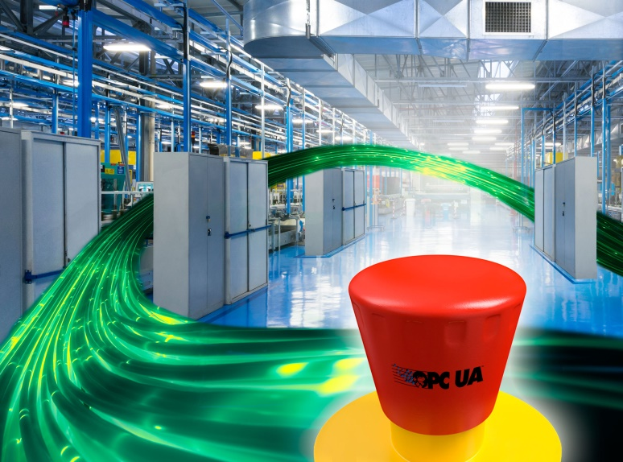

Press contact:
PI (PROFIBUS & PROFINET International)
PROFIBUS Nutzerorganisation e. V.
Barbara Weber

Haid-und-Neu-Str. 7

D-76131 Karlsruhe, Germany
Phone: +49 (0) 721 / 96 58 549

Fax: +49 (0) 721 / 96 58 589
Barbara.Weber@profibus.com
http://www.PROFIBUS.com
The text of this press release is available for download at www.profibus.com.

